## UC-08: Adding a route:

|  |  |
| --- | --- |
| **Section** | **Content / Explanation** |
| **Designation** | UC-08 |
| **Name** | Adding a route |
| **Priority** | Important for system’s success: **High**  Technical Risk: **High** |
| **Scope** | This use case deals with how the Flight Manager adds a route in the FRS . |
| **Criticality** | High |
| **Level** | User-goal |
| **Description** | The Flight Manager selects flight type, enters destination, stops, departure and makes a route. Route is added in the database. |
| **Trigger event** | The Flight Manager wishes to add a new route. |
| **Primary actor** | Flight Manager |
| **Stakeholders and interests** | Passenger: He wants to look at the routes of flight.  Flight Manager: he wants to keep check of every route.  He wants to manage the route. |
| **Pre-Conditions** | The Amin must be logged in.  The Flight Manager must be in the route management portal. |
| **Post-Conditions** | Route is added.  Route records are updated. |
| **Result** | Route added |
| **Main Scenario** | 1. The Flight Manager selects a route option. 2. The FRS displays an add route screen and gives options for direct or indirect flight. 3. Flight Manager selects direct flight. 4. FRS then asks the Passenger for departure and destination city. 5. The Flight Manager enters departure and destination. 6. FRS gives Flight Manager the option to   6.1  Confirm the route.  6.2  Cancel the route.  6.3  Change the route.   1. The Flight Manager confirms the route. 2. The FRS checks the database if the route is already present in the database and stores the route if it is not found in the database. |
| **Alternative Scenario** | 3a. The Flight Manager selects indirect flight.       3a.1 The FRS asks the Flight Manager number of stops he wants to enter.        3a.2 The Flight Manager enter the number of the stops he want to add.        3a.3 The FRS asks the Flight Manager to enter the name of stop (city).  5a. The Flight Manager enters departure, stops and destination.  6a. The Flight Manager select cancel the route option.        6a.1 The FRS brings the Flight Manager back to the route management portal.  6b. The Flight Manager selects a change route option.         6b.1 Go to step 4.  8a. The route is already present.         8a.1 The FRS will display message that route is already stored and give Flight Manager the option:  1. Add another route  2. Cancel the route.         8a.2 the Flight Manager select add another route.         8a.3 got to step 4.  8a.2.1 The Flight Manager cancels the route.         8a.2.1.1 The FRS takes Flight Manager to route management portal. |
| **Exception Scenario** | The FRS  server is down.  (2)  Refresh and add the route again. |

**System Sequence Diagram: Adding a Route**

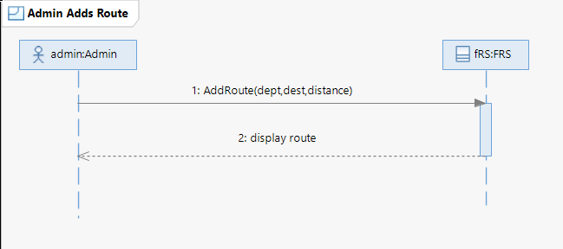

**Sequence Diagram: Add Route**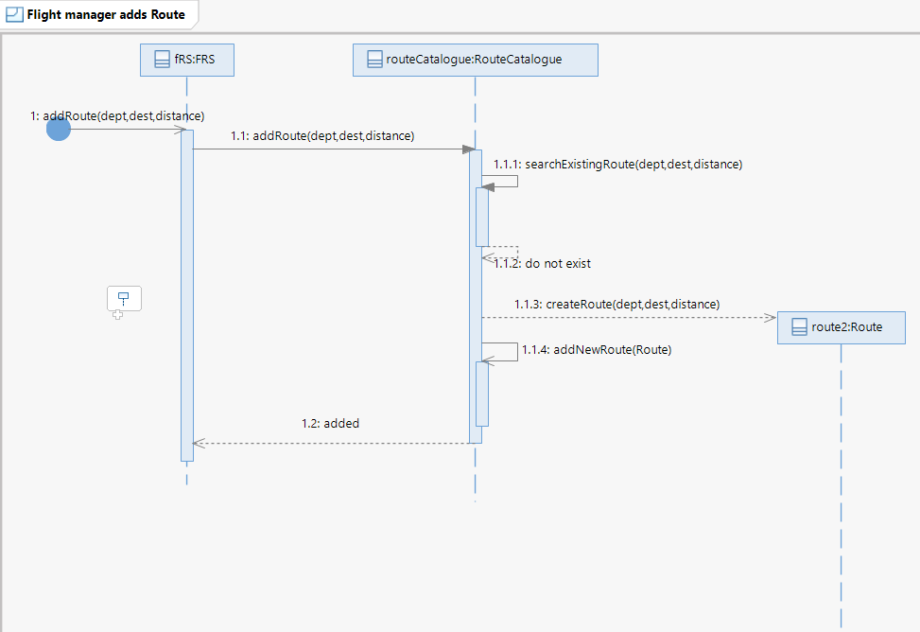

## UC-09: Updating a route

|  |  |
| --- | --- |
| **Section** | **Content / Explanation** |
| **Designation** | UC-09 |
| **Name** | Updating a route |
| **Priority** | Important for system’s success: Medium  Technical Risk: Medium |
| **Scope** | This use case deals with how the Flight Manager updates a route in the FRS . |
| **Criticality** | Medium |
| **Level** | User-goal |
| **Description** | The Flight Manager select the route to change and enter the entries (departure, destinations, stop) he want to change in the route |
| **Trigger Event** | The Flight Manager wishes to update route information. |
| **Primary actor** | Flight Manager |
| **Stakeholders and interests** | Passenger: He wants to check the routes of flight.  Flight Manager: he wants to keep checking every route.  He wants to manage the route. |
| **Pre-Conditions** | The Amin must be logged in.  The Flight Manager must be in the route management portal. |
| **Post-Conditions** | Route is updated.  Route records are updated. |
| **Result** | Route updated. |
| **Main Scenario** | 1. The Flight Manager selects and updates a route option. 2. The FRS will fetch the routes from the database and display routes to the Flight Manager. 3. The Flight Manager selects the route he wants to update. 4. The FRS displays details of route and asks the Flight Manager if he wants to change the departure or not. 5. The Flight Manager selects the change the departure option and enters the new departure. 6. This gives the Flight Manager option if he wants to change the destination or not. 7. The Flight Manager selects to change destination and enters new destination. 8. The systems check if routes contain the stops and ask if the Flight Manager wants to change the stops or not. 9. The Flight Manager changes the stops. 10. FRS display the update route gives Flight Manager the option to   10.1Confirm the route.  10.2 Cancel the route.  10.3Change the route.   1. The Flight Manager confirms the route. 2. The FRS checks the database if the route is already present in the database and updates the route if it is not found in the database. |
| **Alternative Scenario** | 5a. The Flight Manager selects to not change the departure option.       5a.1 Go to step 6.  7a. The Flight Manager selects to not change the destination.       7a.1 Go to step 8.  8a. The route does not contain any stops. cancel the route option.        8a.1 Go to 10  8b. The Flight Manager does not want to change the stop.         8b.1 Go to step 10.  10a. The Flight Manager select cancel the route option.        6a.1 The FRS brings the Flight Manager back to the route management portal.  10b. The Flight Manager selects a change route option.         10b.1 Go to step 4.    12a. The route is already present.         10a.1 The FRS will display message that route is already stored and give Flight Manager the option:  1. Add another route  2. Cancel the route.         10a.2 the Flight Manager select add another route.         10a.3 got to step 4.  10a.2.1 The Flight Manager cancels the route.         10a.2.1.1 The FRS takes Flight Manager to route management portal. |
| **Exception Scenario** | The FRS  server is down.  (1)  Refresh and update the route again. |

**System Sequence Diagram: Updating a route**

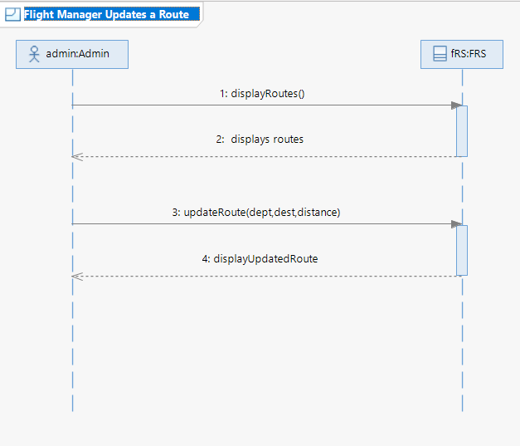

**Sequence Diagram: Updating a route**

1. **Display Routes**:

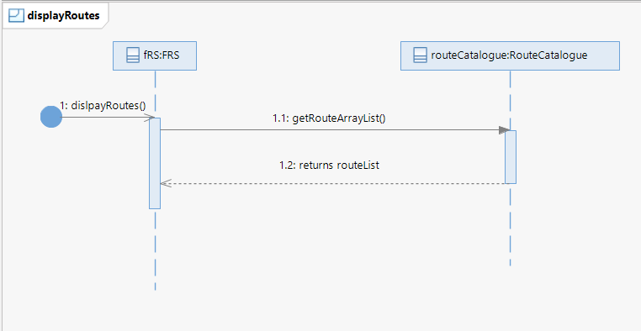

**2. Update Route():**

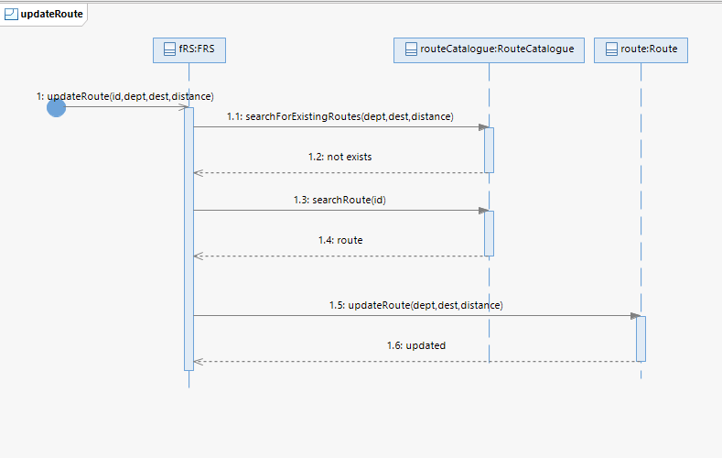

## UC-10: Removing a route

|  |  |
| --- | --- |
| **Section** | **Content / Explanation** |
| **Designation** | UC-10 |
| **Name** | Remove a route |
| **Priority** | Important for system’s success: Medium  Technical Risk: Medium |
| **Scope** | This use case deals with how the Flight Manager removes a route in the FRS . |
| **Criticality** | medium |
| **Level** | User-goal |
| **Description** | The Flight Manager selects the route to remove and the route is removed from the database and information is updated. |
| **Trigger Event** | The Flight Manager wishes to remove the route. |
| **Primary actor** | Flight Manager |
| **Stakeholders and interests** | Passenger: He wants to check the routes of flight.  Flight Manager: he wants to keep checking every route.  He wants to manage the route. |
| **Pre-Conditions** | The Flight Manager must be logged in.  The Flight Manager must be in the route management portal. |
| **Post-Conditions** | Route is removed.  Route records are updated. |
| **Result** | Route removed. |
| **Main Scenario** | 1. The Flight Manager selects a route option. 2. The FRS will fetch the routes from the database and display routes to the Flight Manager. 3. The Flight Manager selects the route he wants to remove. 4. The FRS displays details of the route and asks the Flight Manager for the confirmation. 5. The Flight Manager confirms the deletion. 6. The FRS deletes the route from the database. |
| **Alternative Scenario** | 2a. The FRS database is empty.    2a.1 The FRS gives the Flight Manager the message that the database is empty and navigates the Passenger to the route management portal.    5a. The Flight Manager select cancel the route option.        5a.1 The FRS brings the Flight Manager back to the route management portal. |
| **Exception Scenario** | The FRS  server is down.  (1)  Refresh and remove the route again. |

**System Sequence Diagram: Removing a route**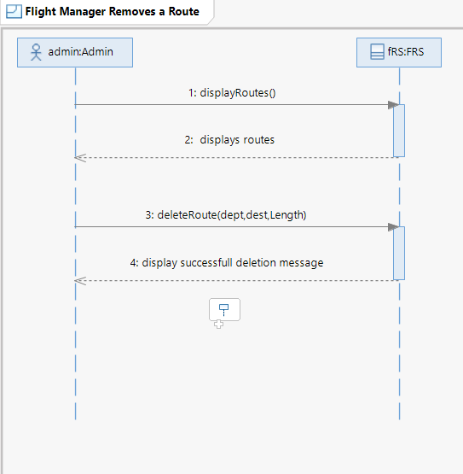

**Sequence Diagram: delete Route**